Trans Panic Narratives Around Mass Shootings

Team: Mathieu, Saewon, Ben
Date: March 2026

Key Takeaways
- Trans panic narratives were a significant but minority part of Tumbler Ridge shooting discussions, driven primarily by influencers. Transgenderism-related content increased substantially after the RCMP confirmed the shooter was a trans woman, but represented a minority of posts about the shooting. Influencers were the main source of these discussions, while news outlets, politicians, and government organizations overwhelmingly focused on other aspects of the event.
- Negative rhetoric dominated engagement with posts mentioning transgenderism, especially association of transgenderism with violence and transgender identity denial. Direct and explicit threats were almost non-existent from prominent Canadian accounts, but could be more common among ordinary users.
- Canadians are deeply polarized on gender identity issues along ideological lines. Only 8% of left-leaning Canadians believe schools are indoctrinating children with gender ideology, compared to 66% of right-leaning Canadians. Age and gender play a more modest role. Social media use does not appear, in and of itself, to be related to these beliefs.
- Despite a hostile online environment, we do not find evidence that transgender and non-binary Canadians are less likely to participate in online political spaces than other Canadians. Transgender and non-binary Canadians report feeling more comfortable expressing their political views online and do so more frequently than cisgender people. These differences hold after controlling for age, political interest, social media use, education, region, and survey wave. These differences do not extend to offline speech.

Context
On February 10, 2026, 18-year-old Jesse Van Rootselaar killed her mother and half-brother at their home in Tumbler Ridge, British Columbia, then walked to Tumbler Ridge Secondary School, where she killed six people and wounded 27 others before dying by suicide. It was Canada's deadliest school shooting since the 1989 École Polytechnique massacre.

The next day, RCMP confirmed that Van Rootselaar was a trans woman. Within hours, a fraudulent X account was renamed to match the shooter's YouTube channel and filled with white supremacist content. A BC MLA tweeted about the ‘transgender violence epidemic’. An unrelated trans woman in Ontario who shared the shooter's surname was misidentified across social media platforms, and briefly by Radio-Canada. Elon Musk and other high-profile figures pushed viral charts claiming trans people are disproportionately responsible for mass shootings, even though trans people account for fewer than 0.1% of mass shooters (5 of 5,748 since 2012). On a Rebel News livestream, commentator Lise Merle called it "a predictable act of trans madness."

This event follows on from three other prominent events in the last few years involving a prominent public shooting, and implications of transgender people in the violence. In 2023, a school shooting occurred in Nashville, and the identity of the shooter was later revealed to be transgender. This event escalated discourse against the ‘trans violence epidemic’. This was followed by the Annunciation shooting, where the shooter was revealed to be trans. The next major event was the assassination of Charlie Kirk, where discourse against ‘trans violence’ initially started due to Kirk’s discussion of the rate of violence of transgender people just before he was shot, followed by the reveal that the shooter’s partner was transgender. It is within this context that the discussion of transgender people occurred with regard to the Tumbler Ridge shooting.

In that context, this incident report evaluates the salience of the trans panic narratives, as well as the volume and nature of toxic speech and threats targeting trans people following the Tumbler Ridge shooting. Using our monthly tracking survey we also evaluate how polarized the Canadian public has become on gender identity, as well as whether non-binary and transgender people feel less comfortable participating in online spaces than other Canadians.

Research Questions
We focus on three questions:
- What was the salience of the trans panic narrative compared to other narratives following the Tumbler Ridge shooting, and what was the source of these narratives?
- What was the nature and reach of negative speech about transgenderism following the shooting?
- To what extent are Canadians polarized on gender identity issues, and does this polarization makes non-binary and transgender people less likely to participate in online spaces compared to other Canadians?

Analysis

What was the salience of the trans panic narrative compared to other narratives following the Tumbler Ridge shooting, and what was the source of these narratives?

We start by evaluating what share of the social media discussions following the shooting mentioned transgenderism. We used social media data from our seedlist of politically influential Canadian entities. We focused on the month of February 2026 and social media posts containing keywords about trans/queer or Tumbler Ridge topics. Figure 2 shows that the number of posts about the Tumbler Ridge shooting spiked on February 11 (all our times are in UTC, so a post on February 10 in BC time might be recorded on February 11 in UTC). The volume of discussions about transgenderism substantially increased after the shooting, although it represented a minority of posts discussing the shooting.

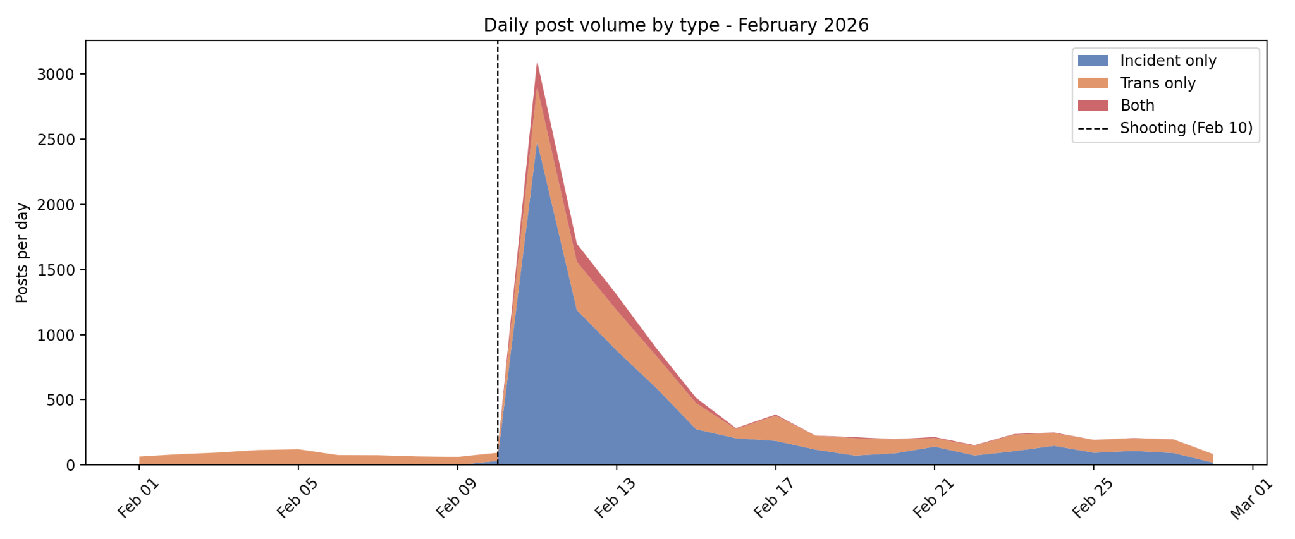
Figure 1. Volume of posting about the Tumbler Ridge shooting and transgenderism (stacked curves)

We next evaluate the source of Canadian discourse about the Tumbler Ridge shooting and transgenderism. Figure 2 shows the number of posts that mentioned the shooting, mention transgenderism, or mentioned both from the day of the shooting to February 28. The results show that influencers, news outlets, and politicians all significantly engaged with the event. Influencers posted the largest volume of content and were clearly the main source of discussions about transgenderism following the event. In contrast, only a small minority of posts from news outlets, politicians, and government organizations focused on transgenderism. In addition, when we analyzed the source of the discourse by age and gender, our findings showed that younger entities posted more about transgenderism than the shooting and males posted more about transgenderism than females.

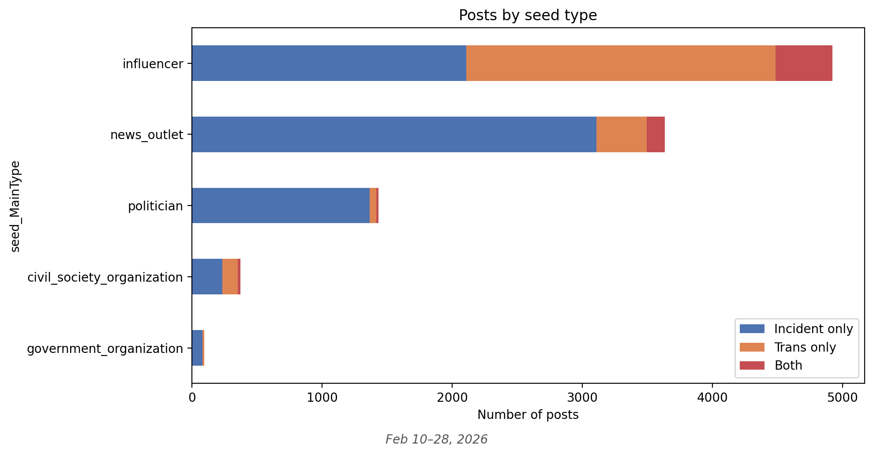
Figure 2. Source of posts about the Tumbler Ridge shooting and transgenderism

What was the nature and reach of negative speech about transgenderism following the shooting?

We next evaluate how much engagement posts about transgenderism received following the shooting and the negative rhetoric that received the most engagement. Using Claude Haiku 4.5, we classified the top 20 posts mentioning transgenderism for each day in February 2026 as to whether they contain rhetoric that attacks, delegitimizes, dehumanizes, or marginalizes trans/queer people (negative rhetoric), and, for those that did include negative rhetoric, coded the theme of the rhetoric into the following categories:
- Violence association: Associating trans people with violence or criminality
- Ideology framing: Dismissing trans identity as ideology, trend, or social contagion
- Conspiracy: Claiming trans movement is driven by hidden agenda/lobby
- Mockery: Ridiculing trans people or identities
- Identity denial: Denying trans identities (e.g., "trans women are men", misgendering)
- Child protection: Using child safety rhetoric to oppose trans rights/existence
- Other: We pooled remaining categories that received less engagement, see Methodology section.

Figure 3 shows that engagement with posts about transgenderism, with engagement concentrated in posts that included negative rhetoric. While we observe an increase of negative rhetoric across all seven themes identified above, posts associating transgenderism with violence or denying transgender identity (e.g., saying that the shooter was a man) received by far the most engagement.
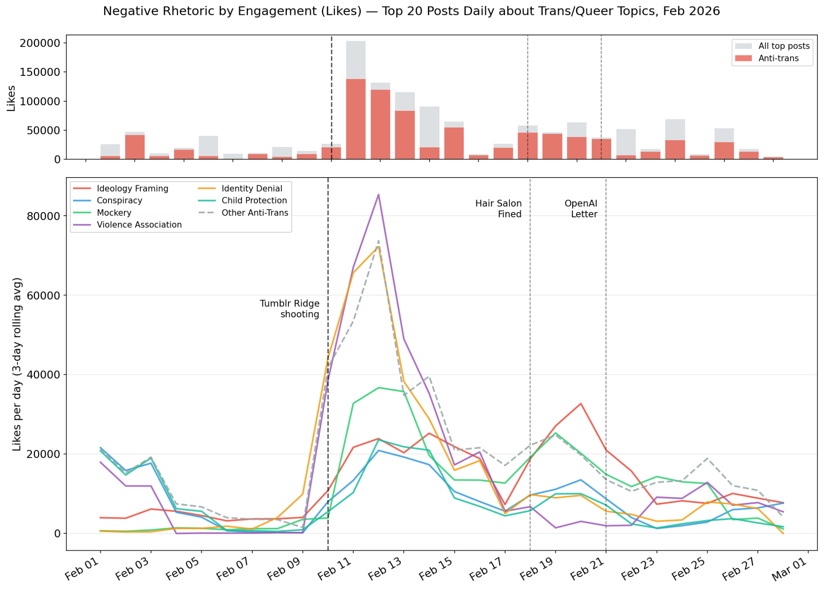
Figure 3. Engagement with posts mentioning transgenderism

We searched for explicit violent threats against transgender people in our datasets on the Tumbler Ridge shooting, the assassination of Charlie Kirk, and the Nashville and Annunciation shootings. For Tumbler Ridge, , we had dataset

To what extent are Canadians polarized on gender identity issues, and does this polarization makes non-binary and transgender people less likely to participate in online spaces compared to other Canadians?

Figure 4 is showing the percentage of Canadians who believe that schools are indoctrinating kids with gender ideology based on age, gender, ideology, and social media use. Ideology is the strongest predictor, with only 8% of left-leaning Canadians believing that to be true, compared to 66% of right-leaning Canadians. We also find that the percentage is slightly higher among older Canadians than younger Canadians, and among men than women. Social media use does not seem, in and off itself, to be related to belief about gender indoctrination.
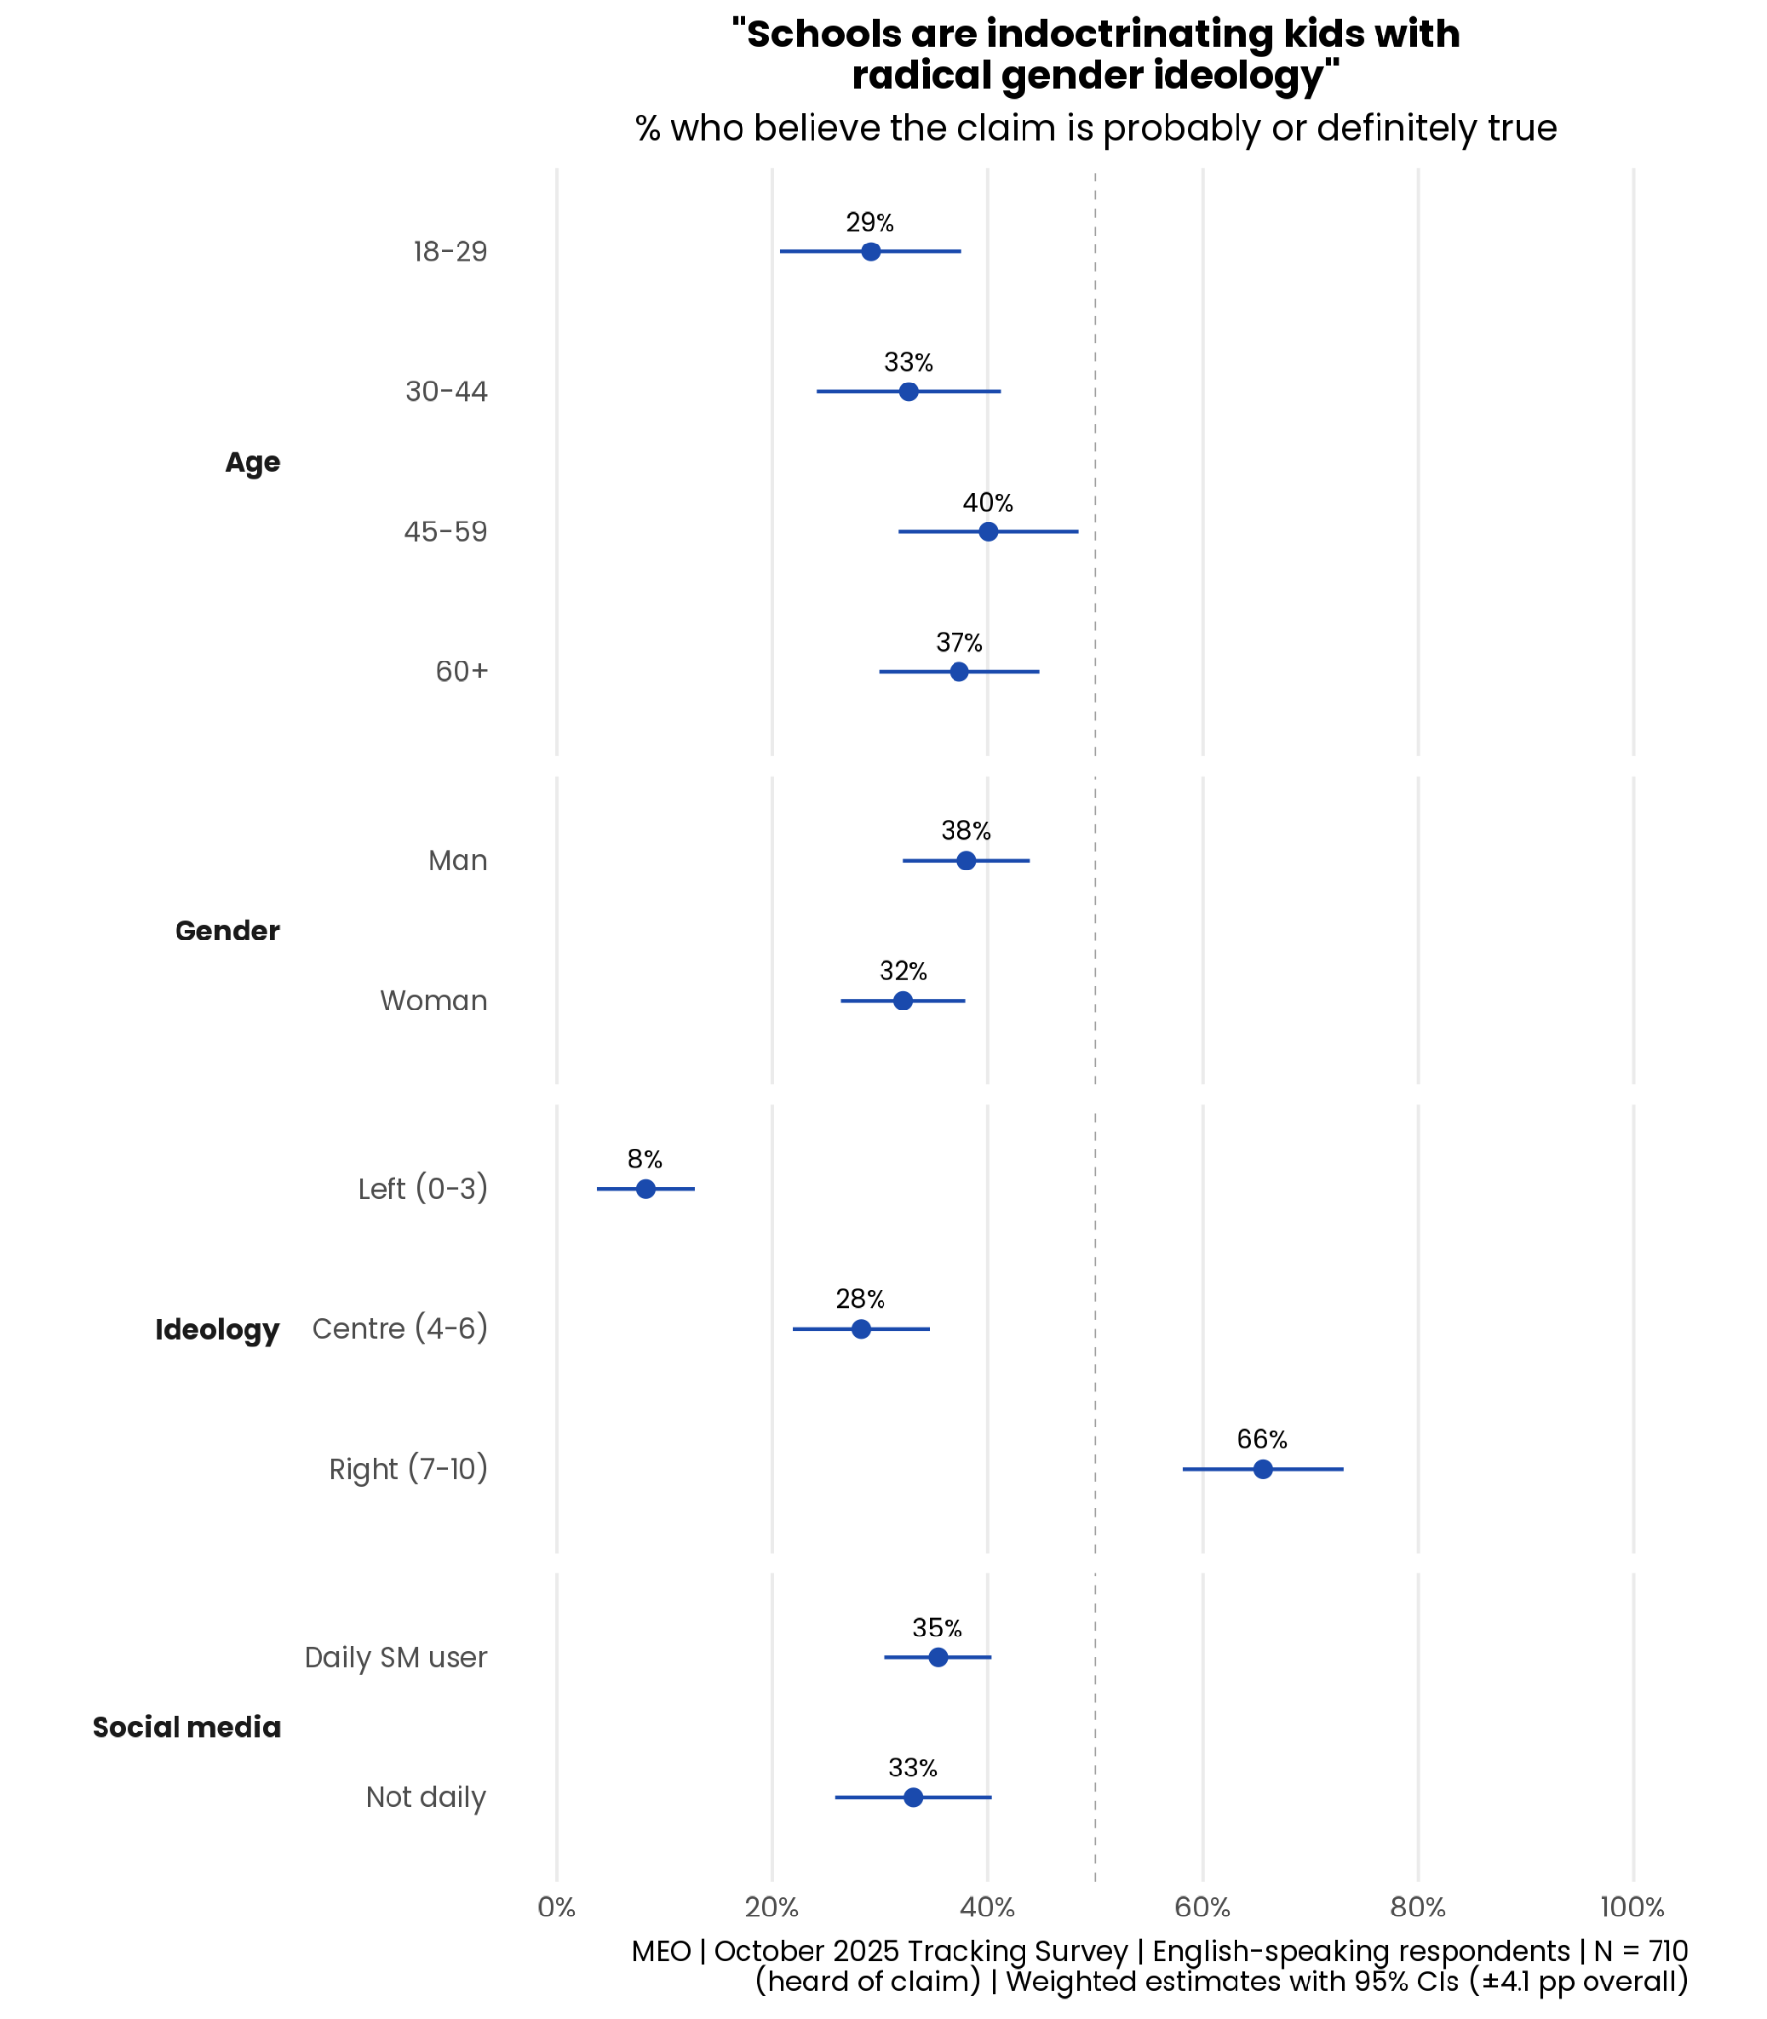
Figure 4. Share of Canadians who believe that schools are indoctrinating children with gender ideology by age, gender, ideology, and social media use

Despite these polarized views, and toxic discourses discussed above, we find that non-binary and transgender generally feel more comfortable expressing their views about politics and do it more often than other Canadians, even after controlling for age, political interest, daily social media use, education, region, and survey wave, see Figure 5. Interestingly, we do not observe the same differences for offline speech. Overall, our findings fit the framework of an activated minority, where transgender and non-binary people are activated to speak up in spite of a hostile climate (but see limitations below).

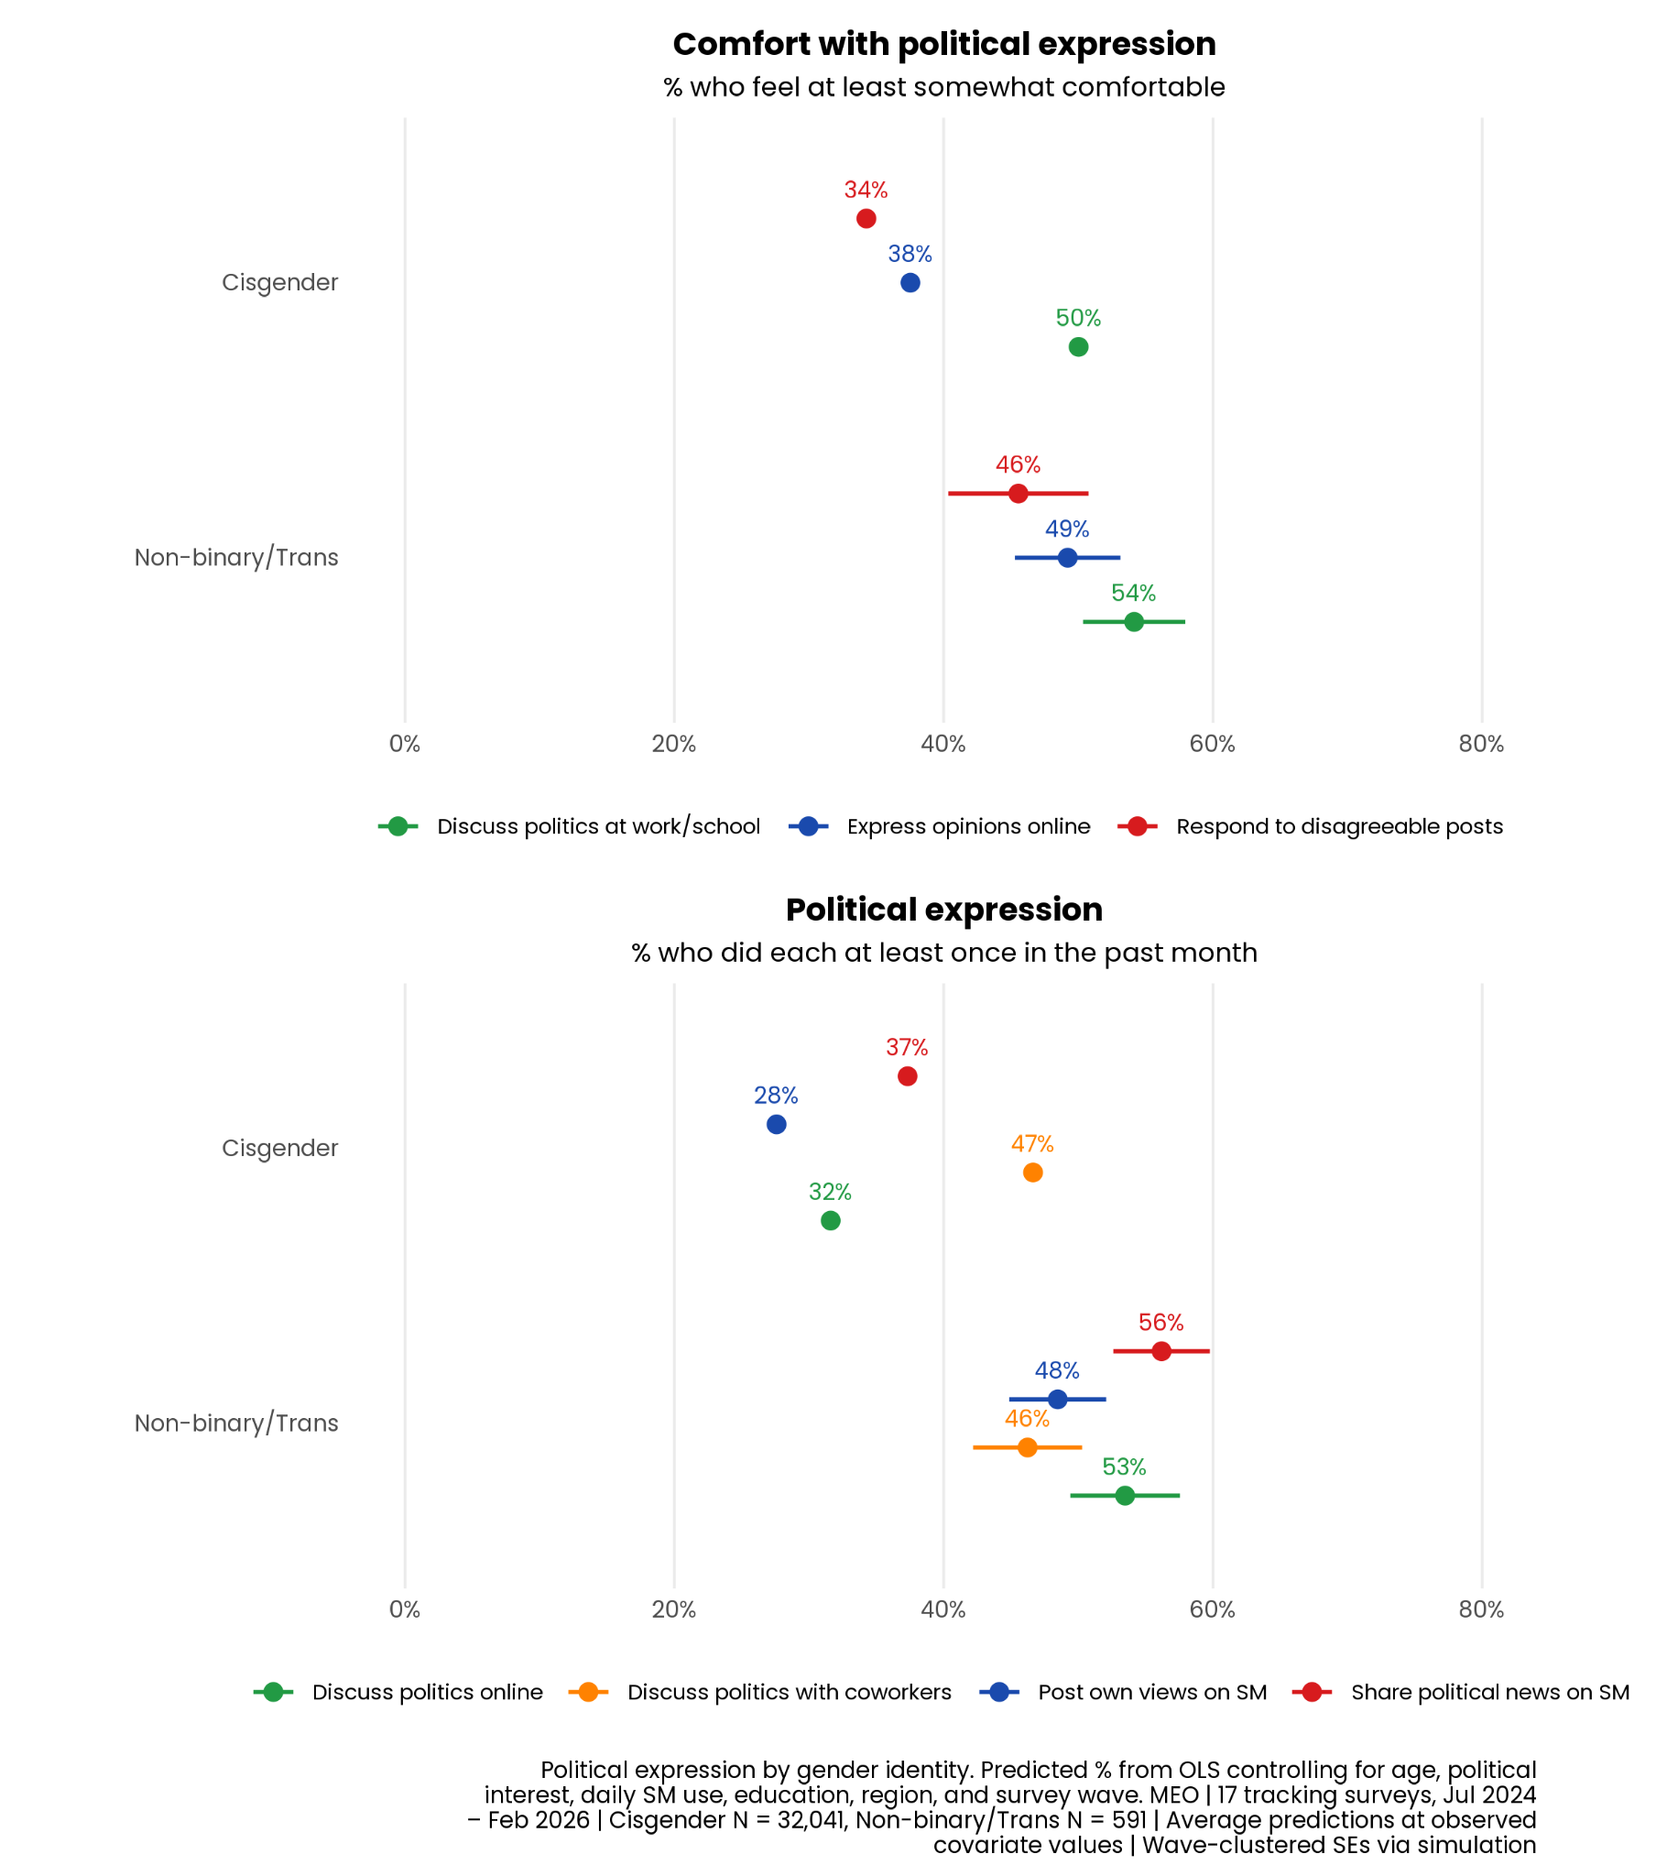
Figure 5. Comfort with political expression and frequency of political expression by gender

Implications and Recommendations

Methodology
Survey data

We evaluate polarization on gender identity questions and how much non-binary and transgender people are willing to participate in online spaces compared to other Canadians using our monthly tracking survey from July 2024 to February 2026. Each monthly sample was provided by Léger and aimed to be representative of the national population in terms of age, gender, and region. All analyses use post-stratification weights on age, gender, and region to better approximate the Canadian population. We sampled around 1,500 Canadians per month, for a total of 32,632 respondents.

The question measuring beliefs about gender issues was fielded in the October 2025 survey. A first question asked Canadians about their awareness of some narratives (1= Yes, I have heard of this or something similar, 0= No, I have not heard of this), with a following up questions for those aware asking “Please rate the extent that you believe each statement below is true or false,” with responses on a five-point scale ranging from “Definitely false” to “Definitely true.” Because of a survey-coding error, this question was only asked to English-speaking respondents.

Social media data

We classified social media posts from our seedlist with Haiku 4.5, using the following prompt:

SYSTEM_PROMPT = """You are a content analyst studying public discourse about trans and queer people in Canadian social media during February 2026. Your task is to classify social media posts for anti-trans rhetoric.

For each post, provide a JSON object with these fields:

1. "contains_anti_trans_rhetoric": true/false — Does the post contain rhetoric that attacks, delegitimizes, dehumanizes, or marginalizes trans/queer people?

2. "rhetoric_categories": list of strings — Which categories of anti-trans rhetoric are present? Use as many as apply from this list, or add new ones if needed:
- "identity_denial" — Denying trans identities (e.g., "trans women are men", misgendering)
- "pathologizing" — Framing being trans as mental illness, disorder, or delusion
- "predator_framing" — Portraying trans people as predators, groomers, or threats to children
- "ideology_framing" — Dismissing trans identity as ideology, trend, or social contagion
- "child_protection" — Using child safety rhetoric to oppose trans rights/existence
- "sports_exclusion" — Framing trans women in sports as unfair/cheating
- "bathroom_panic" — Framing trans people in gendered spaces as dangerous
- "medical_opposition" — Opposing gender-affirming care, framing it as mutilation
- "erasure_of_women" — Claiming trans rights erase or harm cisgender women
- "dehumanization" — Language that dehumanizes trans people
- "mockery" — Ridiculing trans people or identities
- "conspiracy" — Claiming trans movement is driven by hidden agenda/lobby
- "violence_association" — Associating trans people with violence or criminality
- "elimination_rhetoric" — Calling for removal/eradication of trans people
- "other" — Describe in rhetoric_description

3. "rhetoric_description": string — Brief description of the specific rhetoric used (1-2 sentences).

4. "is_tumblr_ridge_connected": true/false — Is the post related to or referencing the Tumblr Ridge shooting (Feb 10, 2026)?

5. "stance": one of "anti_trans", "pro_trans", "neutral", "mixed" — Overall stance of the post toward trans people.

Respond with ONLY the JSON object, no other text."""

Limitations
The analysis does not allow us to establish a causal relationship. Gender minorities who are open enough to identify as such in a survey may also be more comfortable with political expression generally and more likely to be politically activated.

Annex: Incident Checklist

Information Incident Characteristics

# | Essential Criterion | Key Questions to Evaluate | ✔
1 | Information Manipulation or Disruption | Is there a clear indicator of information manipulation or disruption in/to the Canadian information ecosystem or sociopolitical environment (e.g. polarization, political violence, election interference)?
2 | Severity | Is there a high likelihood of negative developments or implications? Is there a high likelihood that the situation will worsen or expand in scope?
3 | Public Interest | Is the incident relevant to the interests of the public? Is the quality and availability of existing evidence sufficient to meet public interest?
4 | Expertise | Are we able to assess the incident and improve understanding using our methodologies and expertise?

Brief Rational Provided for each Criteria:
Information Manipulation or Disruption: A fraudulent X account was renamed to match the shooter's YouTube channel and began posting white supremacist content — briefly fooling the Anti-Defamation League. An unrelated trans woman in Ontario who shared the shooter's surname was misidentified across X, Reddit, and briefly by Radio-Canada. US influencers — Libs of TikTok, Elon Musk, and others — pushed viral charts claiming trans people are disproportionately responsible for mass shootings. The statistical reality: trans people account for fewer than 0.1% of mass shooters (5 of 5,748 since 2012). Rebel News called it "a predictable act of trans madness."

Severity: We have identified threats being made to harm the safety of trans people. Narratives around violent incidents involving trans people have been weaponized politically to propose policy or legislation that harms trans people.

Public Interest: We have seen a significant spike in posts from media, politicians, and influencers in Canada immediately after the incident unfolded in Tumbler Ridge, which shows that the Canadian media ecosystem was highly interested in the incident. Conversations around transgender people have also shown sustained interesting to the Canadian media ecosystem over the years

Expertise: We are able to document toxic speech and threats against transgender people using our digital trace data, and whether some phases of disinformation following this and similar incident are more conducive to toxicity and violence. We have documented similar patterns of online transgender disinformation following the Charlie Kirk incident. Using our survey, we can also provide knowledge about pushback against gender ideology in Canada and discomfort non-binary and trans people feel in the online space.

We also have data from “other” genders, but the data was too small for analysis.

